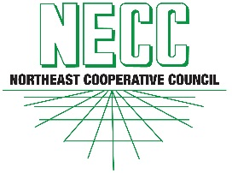
NORTHEAST COOPERATIVE COUNCIL, INC.

Warren Hall, Cornell University, Ithaca, NY 14853

Associate Membership Application

COMPANY NAME:

PRINCIPAL BUSINESS ADDRESS:

MAILING ADDRESS
(if different than business address)

hereby applies for Associate membership in the Northeast Cooperative Council, Inc. (hereinafter referred to as the "Council").

Our company has an interest in Northeast agriculture and/or cooperative business principles or otherwise furthering the interests of the Northeast Cooperative Council.

BUSINESS PHONE NUMBER:

CONTACT PERSON:

CONTACT PERSON EMAIL:

CONTACT PERSON PHONE NUMBER:

This Application is made and has been duly executed by an authorized representative of our organization on ,20 .

Membership fee of $ 550 is enclosed.

Mail completed application with check payable to the Northeast Cooperative Council to:

Malik Davis, NECC Treasurer
Farm Credit East, ACA
4363 Federal Drive
Batavia, NY 14020-4105

